03/10/2022 第四週 線上教室

PTT國會權力的限制第4部分 2015 Capitol 04 2019rev.ppt

前幾頁介紹參議院Vermont、Maine兩位獨立派參議員Bernard Sanders、Angus King，但他們都加入民主黨黨團。所以民主黨黨團48+2實質上有50席。

109屆國會加州眾議員Robert T. Matsui 在2005年初因病過世，補選結果由其妻Doris Matsui繼任，Matsui本來屬加州第5選區，2012年因加州選區調整，原第1選區民主黨議員Mike Thompson改在第5選區參選，Doris Matsui遂改在第6選區參選。現在Thompson仍是加州第5選區眾議員，Matsui是第6選區眾議員，至於第1選區2012年即由共和黨Douglas Lee LaMalfa當選迄今。這幾頁主要目的是看一下眾院議員係分割為若干單一選取，第5選區在沙加緬度，也是加州州政府所在地(不是洛杉磯也不是舊金山)。

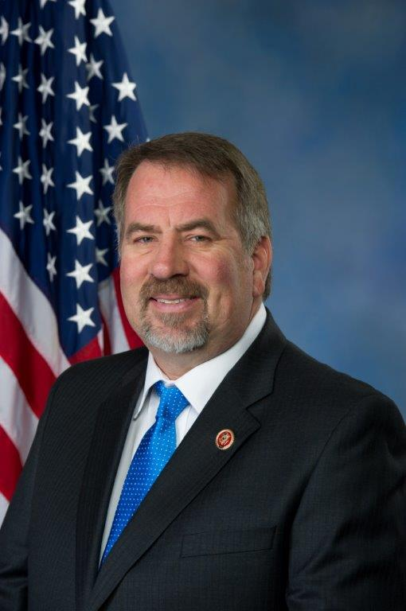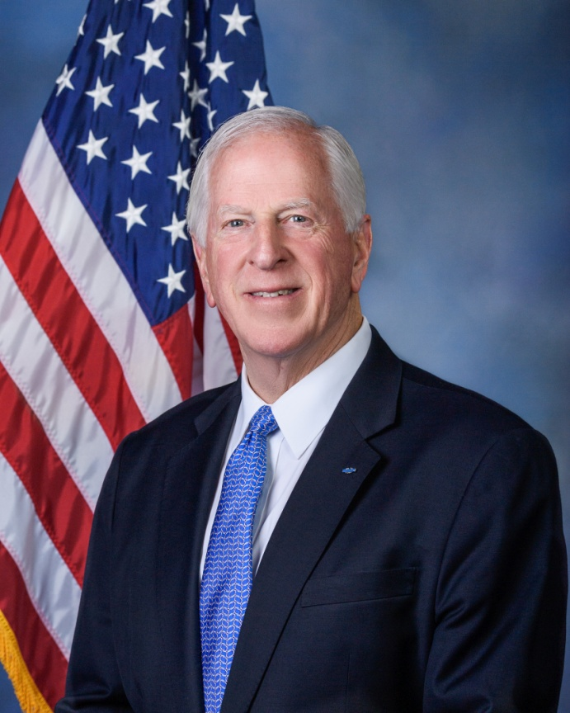

圖左 Doug LaMalfa  (R- California 1st Congressional District)

圖右Mike Thompson (D- California 5th Congressional District)

選區重劃後下屆2022選舉加州會減少一席。(期中選舉在2022年11月8日，11月第一個週一[11/7]過後的週二[11/8])

New York, Illinois, Michigan, Ohio, Pennsylvania and West Virginia each lost a seat, in addition to California. Texas gained two seats, and Colorado, Florida, Montana, North Carolina and Oregon each gained one.

<https://www.latimes.com/politics/story/2021-04-26/census-data-redistricting-delay>

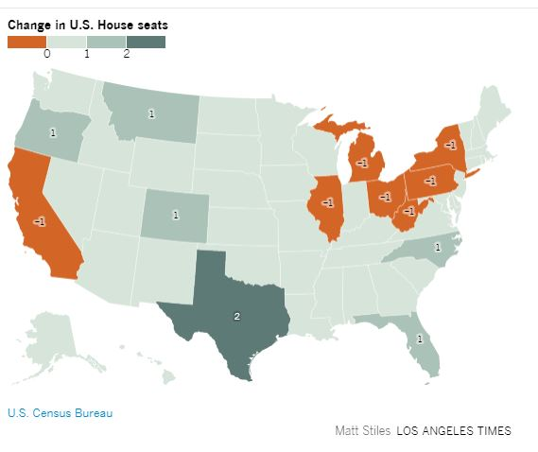

PTT第21頁談到總統不簽署也不退回的法案期滿會自動生效，這種情形極少發生，有名的案例是1995年美國駐以色列大使館要從特拉維夫搬到耶路撒冷：**Jerusalem Embassy Act of 1995**，此法案(104屆國會S.1322)當時因兩院均以高比例通過 (Senate 93–5 and the House 374–37) 因兩院贊成票均超過2/3，事實上總統無法否決(如果否決~退回國會移請覆議，兩院第二次表決必然都超過2/3推翻否決的門檻)，柯林頓總統因此既未簽署也未退回，期滿自動生效，但此法有一條款，總統如認為難以執行，可以簽署一命令暫緩執行，所以歷任總統均暫緩執行，直到川普總統任內，在2018年5月14日美國駐以色列大使館正式遷移至耶路撒冷。

講義第八章p.210.box 8-1. 立法的四種類型

每一議案均有編號，編號前依議案性質有字母縮寫，以S縮寫開頭之案即為參議院(Senate)所首先提出、通過，以H開頭之案即為眾議院(House)所首先提出、通過。總統否決某案，退回國會首先通過的那一院，究竟哪一院，依該案字母縮寫即可知。

議案的四種型態：法案Bill、聯合決議案Joint Resolution、共同決議案Concurrent Resolution、(簡單)決議案 (Simple) Resolution—正式名稱為參議院決議案Senate Resolution、眾議院決議案House Resolution

議案編號：四種議案每屆國會依其自參議院或眾議院提出的區別，有八種編號系統，每種在編號前有一字母縮寫

法案：S.1234, H.R.1234

聯合決議案：S.J. Res.1234, H.J. Res.1234

共同決議案：S.Con.Res.1234, H.Con.Res.1234

簡單決議案：S.Res.1234, H.Res.1234

議案編號的數字係每屆國會兩年任期為範圍，新國會集會後，所有編號均重頭開始。

因此，每逢見到某一議案編號時，首應確定者，即係此案為哪一屆國會之案，或哪一年亦可(每屆國會任期兩年：國會任期自單數年元月三日中午12時開始，至下一單數年元月三日中午12時為止)

參議院沒有屆別，但國會有屆別，因此引述某一參議院議案時，可以稱為”第某屆國會”參議院某某案，不能稱為”第某屆參議院”…….

以下為參議院官網對四種型態議案的說明：

**Bills**

Bills are prefixed with H.R. when introduced in the House and S. when introduced in the Senate, and they are followed by a number based on the order in which they are introduced. The vast majority of legislative proposals are in the form of bills. Bills deal with domestic and foreign issues and programs, and they also appropriate money to various government agencies and programs.

Public bills pertain to matters that affect the general public or classes of citizens, while private bills affect just certain individuals and organizations.

A private bill provides benefits to specified individuals (including corporate bodies). Individuals sometimes request relief through private legislation when administrative or legal remedies are exhausted. Many private bills deal with immigration–granting citizenship or permanent residency. Private bills may also be introduced for individuals who have claims against the government, veterans' benefits claims, claims for military decorations, or taxation problems. The title of a private bill usually begins with the phrase, "For the relief of. . . ." if a private bill is passed in identical form by both houses of Congress and is signed by the president, it becomes a private law.

When bills are passed in identical form by both Chambers of Congress and signed by the president (or repassed by Congress over a presidential veto), they become laws.

**Joint Resolutions**

Joint resolutions are designated H.J. Res. or S.J. Res. and are followed by a number. Like a bill, a joint resolution requires the approval of both Chambers in identical form and the president’s signature to become law. There is no real difference between a joint resolution and a bill. The joint resolution is generally used for continuing or emergency appropriations. Joint resolutions are also used for proposing amendments to the Constitution; such resolutions must be approved by two-thirds of both Chambers and three-fourths of the states, but do not require the president’s signature to become part of the Constitution.

**Concurrent Resolutions**

Concurrent resolutions, which are designated H.Con.Res. or S.Con.Res., and followed by a number, must be passed in the same form by both houses, but they do not require the signature of the president and do not have the force of law. Concurrent resolutions are generally used to make or amend rules that apply to both houses. They are also used to express the sentiments of both of the houses. For example, a concurrent resolution is used to set the time of Congress’ adjournment. It may also be used by Congress to convey congratulations to another country on the anniversary of its independence. Another important use of the concurrent resolution is for the annual congressional budget resolution, which sets Congress’ revenue and spending goals for the upcoming fiscal year.

**Simple Resolutions**

Simple resolutions are designated H.Res. and S.Res., followed by a number. A simple resolution addresses matters entirely within the prerogative of one house, such as revising the standing rules of one Chamber. Simple resolutions are also used to express the sentiments of a single house, such as offering condolences to the family of a deceased member of Congress, or it may give "advice" on foreign policy or other executive business. Simple resolutions do not require the approval of the other house nor the signature of the president, and they do not have the force of law.

以上內容幾乎與講義所述相同

<https://www.senate.gov/legislative/common/briefing/leg_laws_acts.htm>

聯合決議案與法案均有法律效力，均須總統簽署，聯合決議案常見的用途在處理特定目的的單一撥款 (年度撥款法有好幾案，此處僅有一案)。這裡所指的是繼續撥款決議案，以下會介紹。

The joint resolution is generally used for continuing or emergency appropriations.

(此處的緊急撥款是指追加撥款)

講義14章p.416 第三段列舉三種型態的撥款法

年度撥款法(12個)、繼續決議案、追加撥款法

所謂繼續決議案，即因財政年度(前一年10月1日起至當年9月30日止)已開始，但年度撥款法尚未完全立法完成，因此先通過一短期政府支出許可決議案，沿用上一年度的撥款法標準，繼續實施或打折實施，此即為繼續決議案，因須具備法律效力，所以是以聯合決議案的方式訂定。

繼續決議案通常均為短期適用，有時因政治因素(例如總統選舉結果勝負未定: 2000年)，繼續決議案可以持續一再通過，直到爭議解決為止。

這可在撥款法網頁中看到：

<https://crsreports.congress.gov/AppropriationsStatusTable>

Select Year:選 2001

APPROPRIATIONS STATUS TABLE 選 CONTINUING RESOLUTIONS

當年(FY2001)共計有21個繼續撥款決議案，直到12月布希確定勝選為止。

在以上網頁中兩院院會通過一欄(Initial Passage)標示UC 為unanimous consent一致同意(第八章講義p.229最後一段特別討論此種參議院的主要通過立法的方式)此種方式表決時主席僅詢問有無任何人反對，無人反對即可獲得一致同意通過。如有一人反對，即無法認為一致同意，多數黨領袖如仍欲堅持表決，便須另循正式動義的方式進行，但此動議可以討論，反對者可利用其無限制發言(時間)的參議員特權，以持續發言阻擋表決。

另一標示為voice vote口頭表決，這與一致同意不同，係以口頭回答贊成(Aye)、反對(No) 的表決方式，決定何者多數。通常口頭表決多用在不重要的議題表決上~~因沒有明確的投票紀錄(誰贊成、誰反對)。重要的表決必定採記名表決。

至於2021年(FY2022)的繼續撥款法(2021年10月1日以後即為Fiscal Year 2022)，H.R.5305，名為「延長經費與緊急協助法」，繼續撥款至12/3/2021，國會研究處Congressional Research Service的撥款法狀態表中，將此案同時列入繼續決議案與追加撥款法中，此案因眾院9/21通過的版本包含暫停舉債法定上限的爭議，最後移除此項內容，才趕在9/30 完成立法：

### APPROPRIATIONS STATUS TABLE

|  |  |  |  |  |  |  |  |  |  |  |
| --- | --- | --- | --- | --- | --- | --- | --- | --- | --- | --- |
| **Appropriation Bills** | **Subcommittee Approval** | | **Committee Approval** | | **Initial Passage** | | **Resolution of House-Senate Differences** | | | **Presidential Approval** |
|  | **House** | **Senate** | **House** | **Senate** | **House** | **Senate** | **Conference Report** | **House** | **Senate** |  |
| FY2022 Extending Funding and Emergency Assistance Act (through 12/3/2021)  [H.R. 5305](http://www.congress.gov/cgi-lis/bdquery/z?d117:H.R.5305:) |  |  |  |  | [220-211](https://clerk.house.gov/Votes/2021267)  09/21/2021  [Special Rule](https://www.congress.gov/bill/117th-congress/house-resolution/667)  See (+) note |  |  | [254-175](https://clerk.house.gov/evs/2021/roll311.xml)  09/30/2021 | [65-35](https://www.senate.gov/legislative/LIS/roll_call_lists/roll_call_vote_cfm.cfm?congress=117&session=1&vote=00397)  09/30/2021  See (+) note | P.L. 117-43  09/30/2021 |
| [Close Notes](https://crsreports.congress.gov/AppropriationsStatusTable?id=2022) | | | | | | | | | | |
| On September 20, 2021 the House Rules Committee considered a special rule for the floor consideration of three bills including [H.R. 5304](https://www.congress.gov/bill/117th-congress/house-bill/5304), a House measure containing continuing appropriations through December 3, 2021 and supplemental appropriations for: disaster response, to support Afghan evacuees, and for other matters. On September 21, 2022 the Committee reported, a subsequent special rule for the floor consideration of [H.R. 5305](https://www.congress.gov/bill/117th-congress/house-bill/5305), a subsequent measure that would also provide continuing appropriations through December 3, 2021, as well as supplemental appropriations for disaster relief and Afghan evacuees. The House passed the latter measure on the same day, on a roll call vote of [220-211](https://clerk.house.gov/Votes/2021267).   See also [H. Approps. Cmte. press release](https://appropriations.house.gov/news/press-releases/house-passes-extending-government-funding-and-delivering-emergency-assistance) on House passage of H.R. 5305. (9.21.2021)  On September 30, 2021 the Senate passed an amended version of H.R. 5305 that did not include provisions in the bill as passed by the House on September 21, 2021 addressing a suspension of the federal debt limit.  The House concurred in the Senate amendment and the President signed the measure later on September 30th. | | | | | | | | | | |

相關鏈結請直接進入網頁後再點選：

<https://crsreports.congress.gov/AppropriationsStatusTable?id=2022>

共同決議案無須總統簽署，僅僅是兩院的內規或意見。

憲法規定國會休會三日以上，必須兩院一致，因此國會休會動議均由共同決議案訂定。

為避免週一休會導致必須兩院通過共同決議案的麻煩，週一常舉行簡短的會議—形式性會期 pro forma session，亦即並未真正討論議案，僅形式性象徵國會在會期中。有關形式性會期的進一步資料可參閱國會研究處的報告：Sessions, Adjournments, and Recesses of Congress，此報告已上傳，原始鏈結如下：<https://crsreports.congress.gov/product/pdf/R/R42977>

比較重要的共同決議案是預算決議案。

預算共同決議案：14章講義，pp.423-425

預算決議案未完成(兩院一致通過)，並不影響政府運作，只要撥款法通過即可。

但預算決議案係控制收支的工具，為達成某些抑制財政赤字的目的，預算決議案有時包含了修正現行法---要求某些現行法需與預算決議案所訂財政收支目標一致~所謂「劃一」訓令，因此，後續的「劃一」法案(reconciliation bill)在立法過程中享有討論時間限制的保障，參議院中少數黨因而無法以冗長發言杯葛。這表示多數黨在參議院無須60票超級多數即可順利控制立法結果~預算劃一法案。

閉會(Adjournment Sine Die)

Sine Die為拉丁文意即without day所謂閉會即沒有下次開會的散會，通常指每屆國會兩年任期中最後一次散會，但每屆國會有兩會期session，每一年為一會期，第一會期與第二會期最後一次會議的散會均稱為Adjournment Sine Die。

袋中否決(Pocket Veto)

原本是指兩年任滿時國會閉會，因不足10日，總統不同意的法案無法退回(因國會已閉會)，亦未簽署，所以等於收起來實質上否決之意。但過去亦曾有總統利用第一會期閉會甚至第一會期八月休會(August recess)時做相同的袋中否決操作。

袋中否決會發生的主要原因，在重要的爭議性立法往往需長時間協調，所謂協調是指修改原來的版本，以獲得足夠的議員支持票數，所以多數黨往往要到最後才能提至院會表決，但此時距閉會時間已不遠，所以總統遂掌握此一決定權。

項目否決(line-item veto)

1994年11月期中選舉共和黨獲勝，贏得兩院多數，選前共和黨提出的共同政綱中，有一項即為授予總統針對政府支出的撥款法項目否決權，意即可以部分同意、部份否決，其目的在控制政府支出，降低財政赤字，但憲法並未授予總統項目否決權，因此必須修憲，但修憲案須兩院各自以2/3多數贊成通過後，再送各州批准(須獲3/4州批准即可完成修憲)，修憲提案當時在眾議院順利通過，送參議院後表決結果卻因共和黨人內部爭議，欠缺一票不足2/3贊成，發動修憲失敗後，共和黨改以直接立法的方式制定項目否決法，但此法欠缺憲法的依據，遂成為日後爭議的張本。

1995年以前，共和黨連續40年在眾議院均為少數黨，所以1994期中選舉訂定共同政綱時。共和黨人腦中的印像多為以往民主黨掌控國會，而共和黨人常當選為總統(例如雷根、老布希)，因此將財政平衡的責任賦予總統，是很自然地思考結果。但當時選後形勢完全不同，共和黨掌握兩院多數，總統反而是民主黨的柯林頓，所以項目否決法的實施，引起許多共和黨議員的疑慮，因而提起訴訟。

參議院享有人事同意權---總統所送提名案，以往亦如其他議案，參議員可利用其冗長發言的特權來阻擋，要強制停止冗長發言，須通過停止討論動議，依參議院22號規則，停止討論須獲全體參議員3/5贊成(60票)，但2013(民主黨多數)，2017(共和黨多數)先後透過程序操作，將大部分提名案(2013)及最高法院大法官提名案(2017)停止討論的門檻降至過半數票即可，現在參議院共和黨對拜登總統的提名案完全無力杯葛。

立法程序與政策過程其實所描述的均為同一件事，係以不同學科的角度觀察所得的結果，因此，二者可以相互對照。以立法程序而言，即提案→付委→委員會階段(聽證會→條文審查→委員會通過→向院會提出報告)→編入院會議程→院會討論，表決，通過→送另一院(略)→兩院一致通過(兩院如意見不同，應往返修正，或經由協商委員會協商一致版本，最後兩院一致)→總統簽署(或退回國會覆議)

講義第8章 p.207 圖8-1列出完整的立法過程，此即為整個第8章的架構。

政策定義：依本書作者意見，政策亦即政府對已察覺問題的所言所行。P.401

政策過程：政策制定的過程通常包括四個階段：

議題形成→規劃→通過→執行

相對於立法程序，議題形成實質上即國會多數黨決定哪些立法為國會工作的重點；規劃即國會委員會對各項議題舉行的聽證會、條文審查、撰寫報告；通過即依立法程序完成立法(兩院通過及總統簽署)，執行則屬於國會對行政部門執行政策成效的監督

國會對政策執行的監督，最後的處置仍須回到立法的角色，處置方式不外所需經費的調整，或該項政策立法本身的部分修正或全盤檢討。

授權與撥款，為美國國會的二元財政控制方法，簡而言之，規範某一政府機關或某一政府業務工作的設置、規模、任務，係屬於政策問題，應由主管政策立法的各委員會管轄；另一方面，實際提供政府所需經費的是財政問題，需視實際歲入情況分配可支用金額，係由撥款委員會管轄。國會兩院均僅有一撥款委員會，撥款委員會以外的其他委員會均屬於主管授權法的授權委員會

以下進入下一單元：眾院議程編定

第8章p.214 Scheduling in the House 此節列出眾院的幾種議程表，主要分為兩類：國事日程與院會日程，財政相關議案均納入國事日程，其餘則為院會日程。國事日程係指議案須先經國事全院委員會階段討論，參見p.225 Committee of the Whole

全院委員會法定人數僅需100人，院會則為218人，所以需耗時較久的財政議案先在全委會討論時，不必太多議員出席，其他人可同時參與其他的委員會會議。只需在表決時到場投票即可。眾議院每天表決時間多為傍晚5,6點，黨鞭事前會發布公告。

除國事日程與院會日程外，某些私法案(Private Bill僅針對特定對象適用的法律)另排入私法案日程，適用於全國的立法為公法案Public Bill。

排入日程表的議案未必能提至院會，議案要能到達院會，有兩種途徑：小法案捷徑、大法案(主要循特別規則授權)

大法案major bill 在眾院通常均由規則委員會先為其量身訂做一特別規則，其中規範討論時間分配(廣泛討論總時間，並平分為二，由該案法案管理人bill manager 負責控制，管理人通常為原先提出該案審查報告的委員會主席及少數黨高階委員ranking member)，以及許可提出的修正案為何。特別規則由規則委員會在前一日先向院會報告(預告)，當日提出後循一小時規則進行討論(眾院規則每人取得發言權後最多可講一小時)，議長在預定時間承認規則委員會某一多數黨委員發言權，然後該委員再把發言時間讓一半給規則委員會某一少數黨委員，雙方說完後，其他人如要發言，應向該二委員請求(因所有時間均自原始提案者的一小時中計算)，一小時將結束前，原提案委員即動議停止討論(否則一小時期滿後其他人亦可請求另一小時發言)，表決通過後即停止討論，隨即表決原法案。

第八章講義p.214-6介紹眾議院常用的快速立法捷徑: 停止規則程序，其中特別引述前眾議院規則委員會幕僚主任Donald R. Wolfensberger的論文Suspended Partisanship in the House: How Most Laws Are Really Made，文中有詳細討論停止規則程序已逐漸成為眾院主要的立法工具。詳細問題下次再討論。此論文可自行參閱。

雖然才開學第四週，各位應及早開始準備書面報告，題目只要與課堂主題相關皆可，及早開始準備。也不一定要寫美國國會或美國政治，任何你有興趣深入的題目均可。考慮大家面對線上上課的可能情形，期末考發題與交卷的時間提前一週，會有更多時間寫報告。第15週(05/26)發期末考試題(線上公布)，第16週(06/02)交卷，第17週(06/09)交報告，尚未完成者可以延至第18週繳交。

所以時間不多，各位要儘早開始準備報告。

接下來看影片

2021年1月20 日副總統 Kamala Harris 就職後，主持參議院院會，為三位新任參議員Georgia’s Jon Ossoff and Raphael Warnock, as well as Harris’ replacement in California, Alex Padilla主持宣誓就職。後面並有一段CNN主持人與評論員及國會通訊員(記者)的討論。

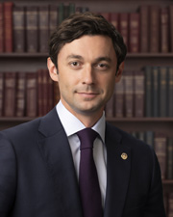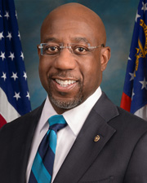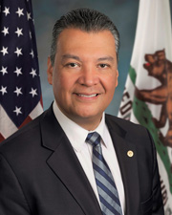

左Sen. Jon Ossoff (D-GA General election)

中Sen. Raphael Warnock (D-GA Special election)

右Sen. Alex Padilla (D-CA Appointed)

2020.11.3.大選，Georgia現任聯邦參議員共和黨David Perdue以49.73% vs. 47.95%得票率領先民主黨Jon Ossoff，但因無人過半數(Georgia州法規定須過半數)，2021.1.5.決選(runoff)，結果Jon Ossoff反而以50.61% vs. 49.39%得票率擊敗David Perdue。

Georgia另一席參議員原本是共和黨的Johnny Isakson，2019.12.31.因健康關係請辭，共和黨籍州長指派Kelly Loeffler接任，2021.11.3.補選(Special election)，民主黨Raphael Warnock 以32.9% vs. 25.9% 領先共和黨現任參議員Kelly Loeffler，2021.1.5.決選(runoff)，結果Raphael Warnock 以51.0% vs. 49.0%擊敗Loeffle，喬治亞州的勝利，使民主黨新增兩席參議員，兩黨變成50 vs.50，再加上副總統

那一票，形成了今天民主黨在參議院的多數(50+1)。

因原任參議員Kamala Harris轉任副總統，所遺參議員一職由州長指派Alex Padilla接任。

Jon Ossoff、Raphael Warnock、Alex Padilla三位參議員的宣誓，正好看到三種參議員的選任方式：定期改選General election、補選Special election、出缺指派Appointed。

以下是CNN字幕相關資料

Vice President Kamala Harris swears in her replacement 08:54 Vice President Kamala Harris swears in her replacement.mp4

Kamala Harris is on the Senate floor for the first time since becoming vice president and is swearing in three senators: Georgia’s Jon Ossoff and Raphael Warnock, as well as Harris’ replacement in California, Alex Padilla. The swearing-in of the three new senators will be groundbreaking. Warnock and Ossoff will be the first Black and first Jewish senators, respectively, representing Georgia, while Padilla will be California's first Latino senator. Ossoff, 33, will also be the youngest senator in the chamber, and the youngest Democrat to serve in the Senate since President Joe Biden, who was sworn into the chamber at the age of 30 in 1973. After Warnock, Ossoff and Padilla are sworn in, the party breakdown of the Senate will be 50-50. Democratic Sen. Chuck Schumer will become the first New Yorker and first Jewish lawmaker to become Senate majority leader. Harris will wield power as the Senate's crucial tie-breaking vote, helping the Biden administration confirm its appointments and giving Democrats the gavels of committees in charge of holding oversight hearings and crafting far-reaching legislation.

KAMALA HARRIS, VICE PRESIDENT OF THE UNITED STATES: the chair lays before the senate two certificates of election for the state of Georgia, and a certificate of appointment certificate of appoint to fill the vacancy created by the resignation of former Senator Kamala D. Harris of California.

(LAUGHTER)

(APPLAUSE)

Yeah, that was very weird. Okay.

The certificates, the chair is advised, are in the forms suggested by the Senate. If there be no objection, the reading of the certificates will be waived and they will be printed in full in the record.

If the senators-elect and senator designate will now present themselves at the desk, the chair will administer the oath of office.

UNIDENTIFIED MALE: Mr. Ossoff, Mr. Padilla, Mr. Warnock.

HARRIS: Please raise your right hand. Okay.

Do you solemnly swear that you will support and defend the Constitution of the United States against all enemies, foreign and domestic, that you will bear true faith and allegiance to the same, that you take this obligation freely, without any mental reservation or purpose of evasion, and that you will well and faithfully discharge the duties of the office on which you are about to enter, so help you God?

UNIDENTIFIED MALE: I do.

HARRIS: Congratulations.

(APPLAUSE)

[16:50:12]

ERIN BURNETT, CNN HOST

BURNETT: So, Bakari Sellers, we are seeing history made again and again and again. And, of course, it all seems to stem from Kamala Harris herself, the vice president. If she speaks here, I'll cut you off. But go ahead.

BAKARI SELLERS, CNN POLITICAL COMMENTATOR: Yeah. No, I think what we saw are an uptick in voters of color throughout the country. All these major cities that dictated the trajectory of this race, Atlanta, Georgia, Philadelphia, Pennsylvania, Milwaukee, Wisconsin, Detroit, Michigan, you saw voters of color come to the forefront. Native American voters in Arizona, Hispanic voters throughout the Sun Belt.

And that's what you're seeing on your screen right now with the swearing in of Ossoff, who's your first millennial United States senator, Raphael Warnock, who is the pastor of Martin Luther King Jr. spiritual home, Ebenezer Baptist Church. And Senator Padilla, the first Hispanic senator from the great state of California.

You're starting to see the Democratic Party look like the demographic changes that are happening in the country.

Let me say something to kind of tie in, Erin, to this conversation we were having, a larger conversation with the 17 House members, one including **Madison Cawthorn**, who was part of inciting the riot that we saw on Capitol Hill. There has been a rise in this country of white supremacy and domestic terror. And this is going to have to be one of the challenges that this administration faces head on from the beginning.

So, yes, we do have the issue of coronavirus, which we have to deal with. We are going to have issues like infrastructure, where you can have some bipartisan resolve. But you're also going to have to deal with the rise of white supremacist domestic terror that we saw storm the capitol on January 6th.

And so, while we're talking about everybody coming together, we have to have accountability before we can get to healing. People want unity, but they don't want any atonement. And so, we have to go through the steps necessary to get there and I anticipate as the Senate changes, as the look of the White House changes, you will begin to see these changes, and us tackling these issues head on as well.

BURNETT: Right, and, of course, the country that has gone through so much. We have now just seen a black Latino, Jewish senators all just sworn in. It is something all happening at once that really kind of only happened in this country.

Something to celebrate, that the world looks to. Of course, you see the vice president there on the floor of the Senate, and Majority Leader Chuck Schumer. Stand by. We're going to talk more about this in 30 seconds.

(COMMERCIAL BREAK)

BURNETT: I want to go to Phil Mattingly at the White House right now.

Phil, you are learning new details about what's happening at this moment there?

PHIL MATTINGLY, CNN CONGRESSIONAL CORRESPONDENT: Yeah, that's exactly right. Joe Biden is officially in the oval office. Obviously, we saw him walk into the White House. We saw him walk into the West Wing. He is now in the Oval Office.

That is for a couple of reasons. One, he is expected to sign those executive actions we've been discussing some time within the next 15 or 20 minutes, but also something to keep in mind here. There is a letter in the Resolute Desk that was left by president Trump.

We don't know what that letter entails. We've got no sense from the White House whether or not we will ever find out what that letter entails. We usually get some sense of it later on in the process. That is something that is in the Resolute Desk that the new president will be able to open the drawer and look at, as all his predecessors have done before.

President Trump did not attend inauguration. President Trump never conceded the race. President Trump never congratulated President Biden or Vice President Harris. But that note is in there. So, that's one element of this.

But I think the other thing is what we'll see, Erin, is what we're going to see here in about 15 or 20 minutes, where the vice president is officially taking the actions that we've been talking about, taking the actions on climate change, taking the actions on COVID, taking the actions on reversing, reversing many of the key priorities that his predecessor put into place.

[16:55:08] I think that's going to be a key thing to watch out for as he starts to do this, Erin.

BURNETT: All right. Certainly.

You know, as you point out, when it comes to that letter, we usually find out what they say, but this is such a very different time, we don't know if we will.

I want to just give you a chance and to react to what we're seeing on the floor of the Senate right now. And that is history being made.

As I pointed out again, related to Kamala Harris herself, right? Her vacancy in California resulting in the first Hispanic senator from the state of California, right, and this entire election, resulting in Georgia flipping to two Democratic Senate seats. So, you have a millennial, Jewish man, a black pastor all now sworn in to the United States Senate. It shifted the balance of power, but it is an incredible look at the diversity that we would see here in America.

ANA NAVARRO, CNN POLITICAL COMMENTATOR

NAVARRO: I know, Erin. When I hear you say it, it's almost like you're introducing a joke, right? A black, Latino and Jewish guy walks into the Senate, and this happened.

But listen, I think -- I have been struck by how many friends of mine, how many people from around the country, of all ages, of all races, of all ethnicities have told me the amount of pent-up emotion and how emotional today was for them. I think we underestimated, many of us -- I know it's not the entire country, but many of us just how stressful, how difficult, how dark the last four years have been for so many.

To see such deliberate acts of inclusion in this ceremony -- listen, Kamala Harris is the first vice president who is a woman and she's African-American. And she's also, you know, from Indian descent. But she chose Sonia Sotomayor, the first Latina, the wise Latino, to swear her in. And she chose Thurgood Marshall's bible to swear in on. So, I think it's there's a deliberate step by step, we are including everybody, we are trying to be historical and just, you know, heal the wounds that we're all feeling.

(COMMERCIAL BREAK)

[17:00:00]